TMB DRR for 401 error in uat
Revision control:
Version | Prepared By | Changes/Comments | Project/Ticket Number | Date
0.1 | MSS Team | Draft | #6897 | 8-07-2025

Participants:
  - MSS Team
- Saikrishna

Step-1
./apicops iss
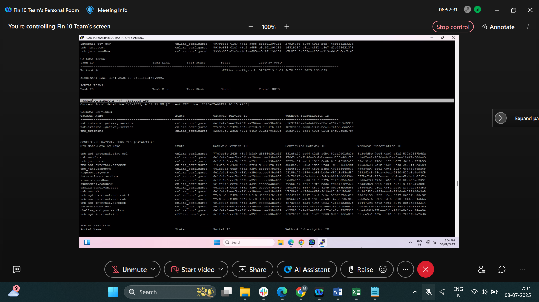
Step 2
Copy file name
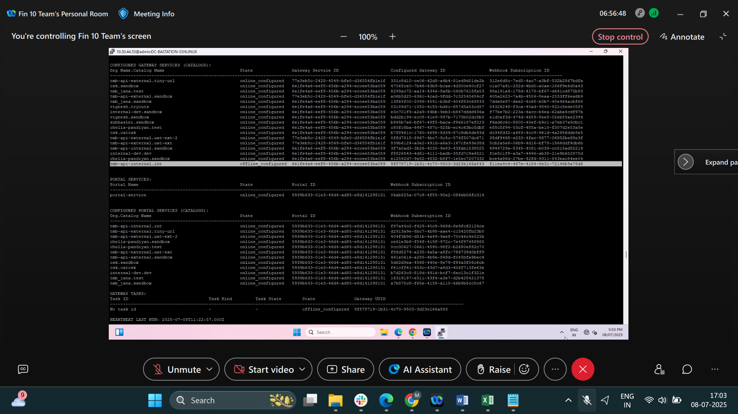

Step 3
./apicops webhook-subscriptions:update -w f11ea9c4-467e-4184-8e31-72146b9a75d6 -s online

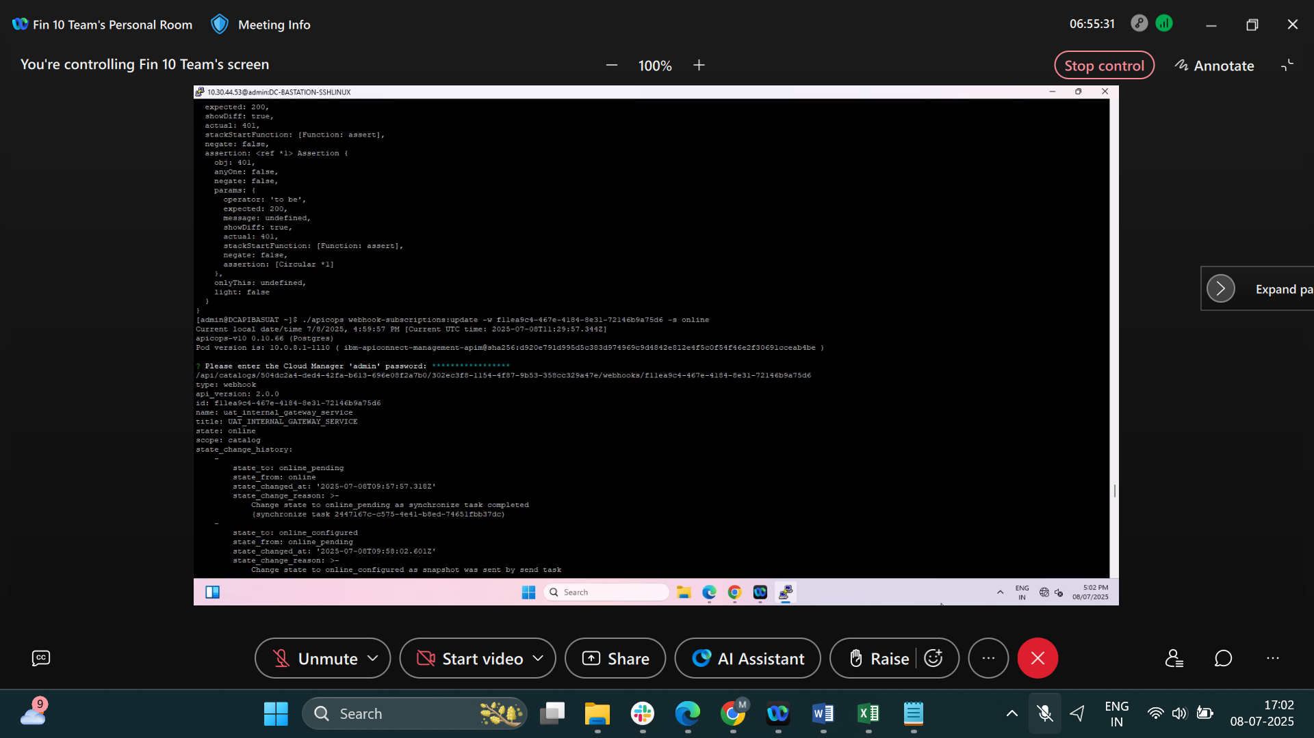

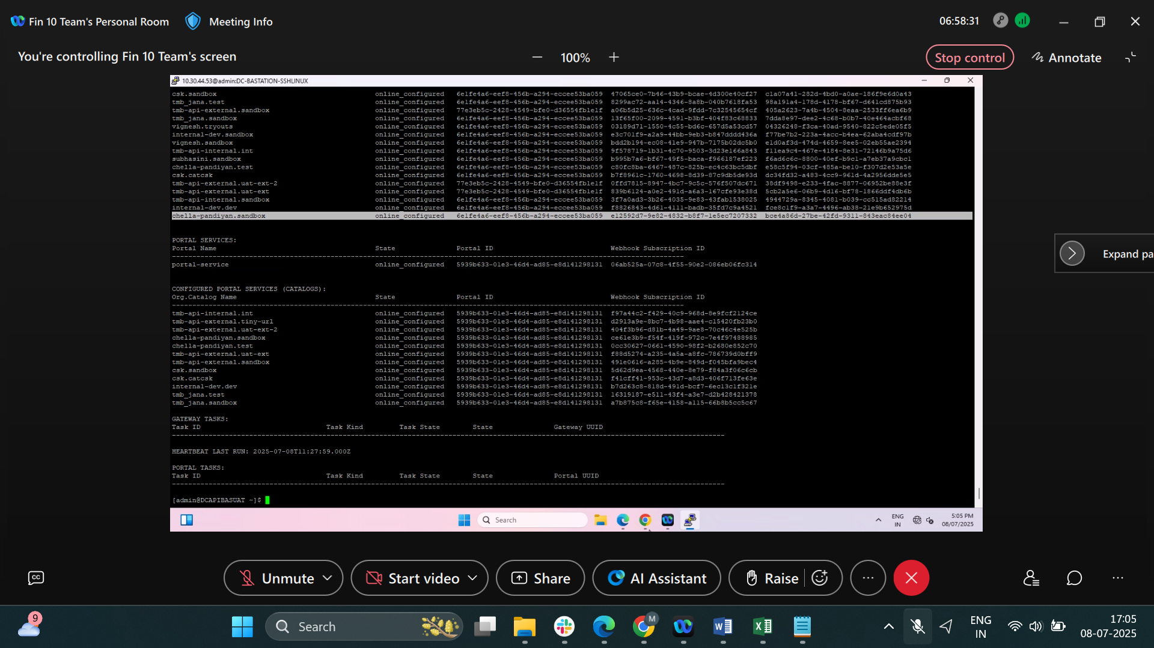

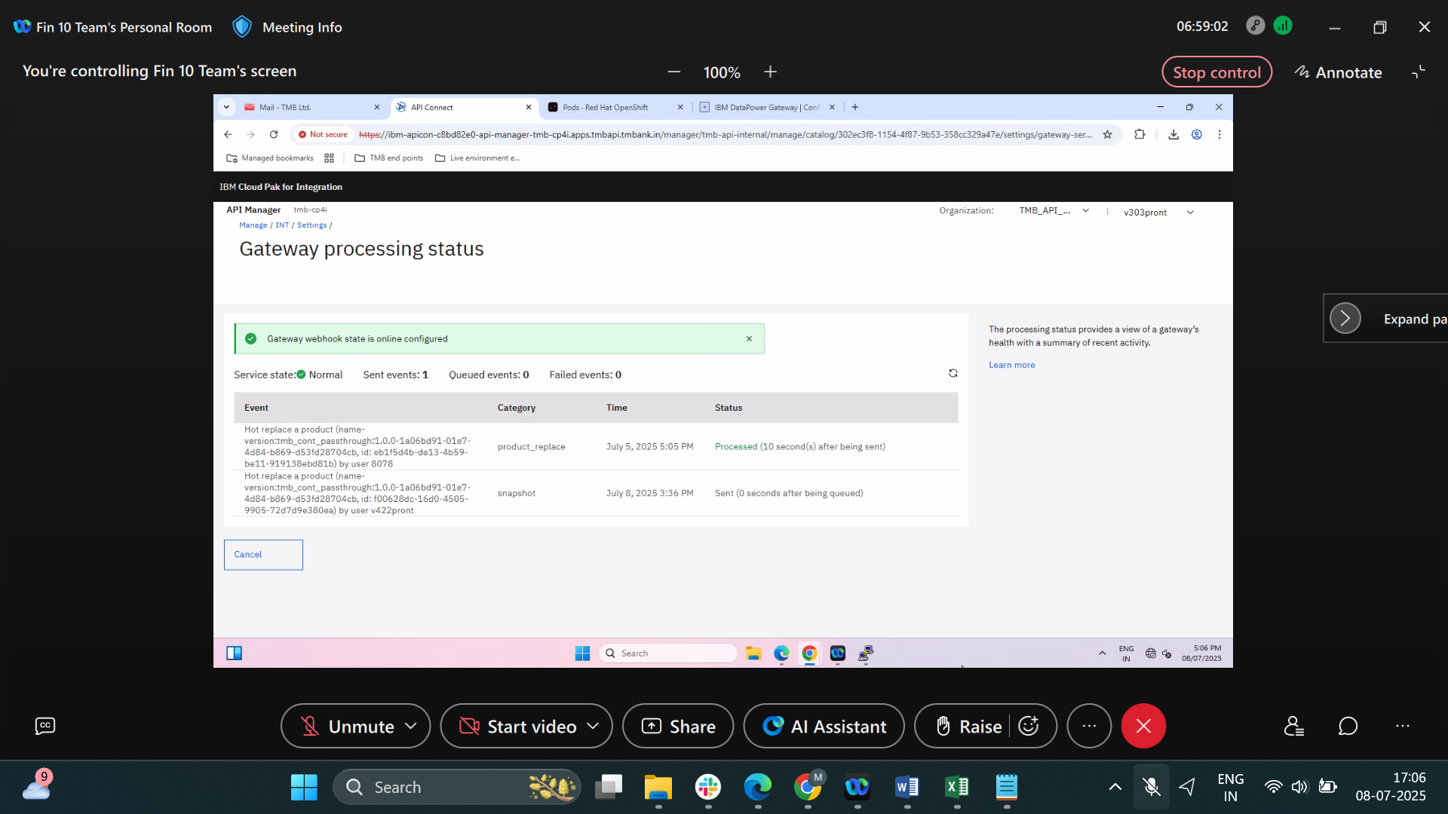

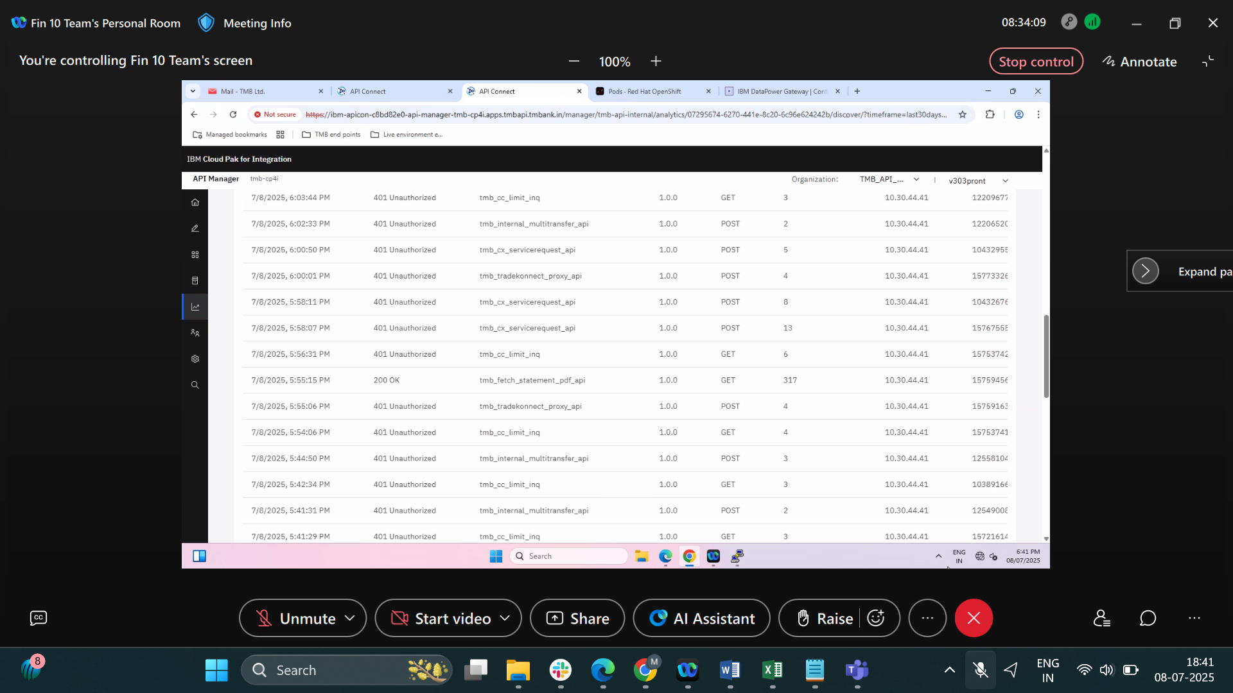

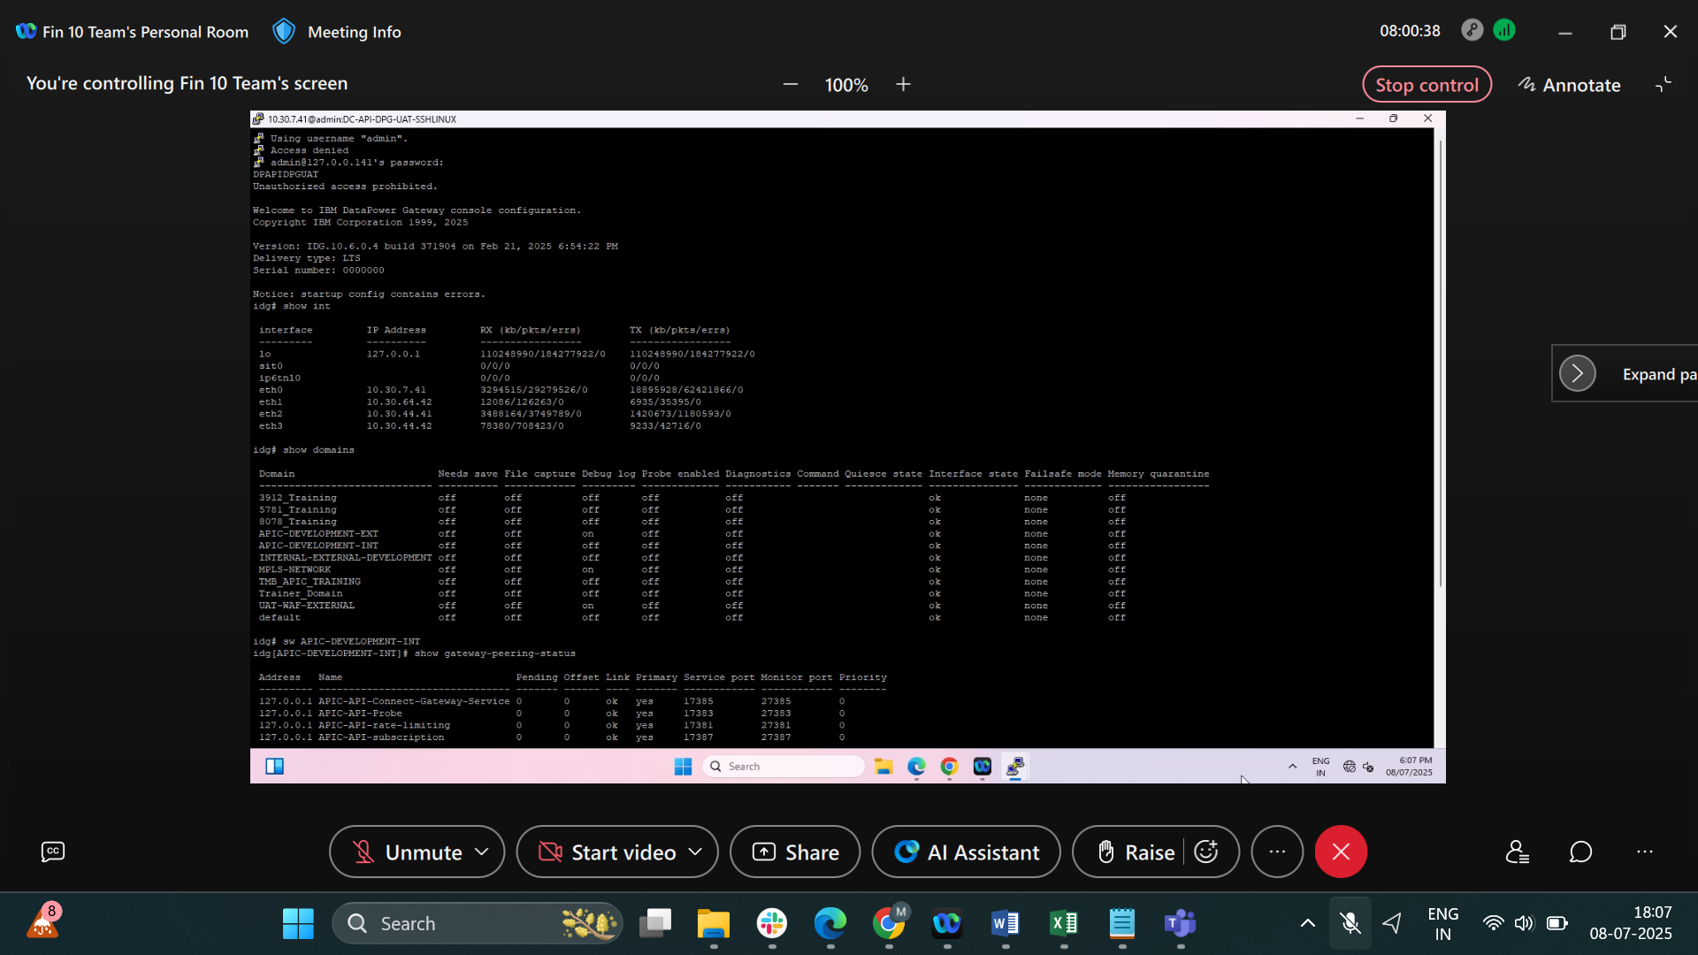
diag; gateway-peering-flush APIC-API-Connect-Gateway-Service; exit

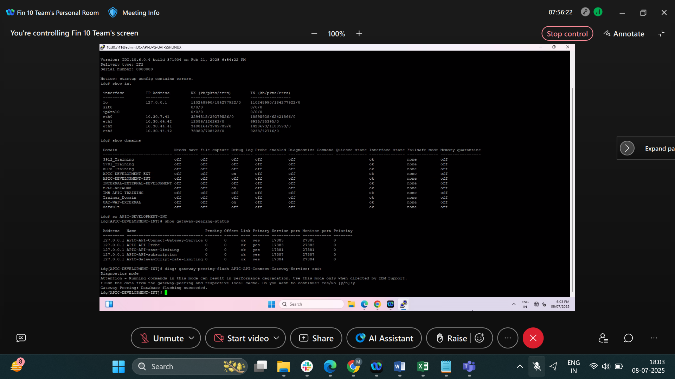

Step 4
config; apic-gw-service; admin-state disabled; exit
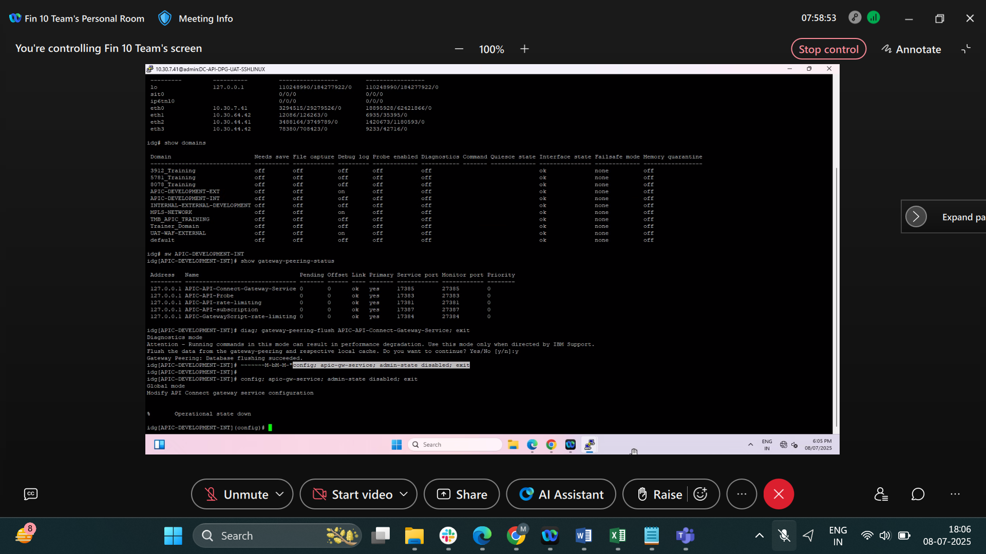

Step 4
apic-gw-service; admin-state enabled; exit
